Enigma 3.0 – Journey + Planning
- [11 April 2025 – 19:53]
- So this project is not going to be easy and it will be different from every other project I ever made, so this project will not have a single .py file with hundreds of lines of code, instead the whole project is divided into 13 different modules –
  - Main.py – Will import (other modules) and will execute all the other things
  - mydata.py – Will store all the data, like keys and lists
  - encrypt_plain.py – Will execute encryption of plain text
  - encrypt_txt.py – Will execute encryption of .txt files
  - encrypt_pdf.py – Will execute encryption of .pdf files
  - encrypt_doc.py – Will execute encryption of .docx (Word document) files
  - documentation.py – Will have all the documents and other things
  - decrypt_plain.py – Will execute decryption of plain text
  - decrypt_txt.py – Will execute decryption of .txt files
  - decrypt_pdf.py – Will execute decryption of .pdf files
  - decrypt_doc.py – Will execute decryption of .docx (Word document) files
  - exception_handler.py – It will have all the exception handling properties where we will have many custom exceptions, like short code length, file not found, same file exists and other things

- These encryption and decryption modules will not store the decoded of encoded material in .txt files, instead they will store in same file types like txt to txt, docx to docx, pdf to word to pdf, etc.

- Skills needed for this project –

  - Functions and parameters
  - If-else and loops
  - Data manipulation
  - Data types and their methods
  - *Self made modules and importation of them
  - Modules –
    - *pdfplumber
    - *python-docx
    - sys
    - random
    - os
    - Time
    - ….
  - *If __name__ == “__main__”
  - Try-except-finally….
  - *ANSI escape codes for different colours text
  - Logic skills for security of messages
  - * - Skills I lack or weak in one

- New things \ New lessons I will have –
  - Self made module
  - Use official document to learn
  - Patience
  - Debugging skills
  - Will experience how coding at bigger level take place

- So this project will not be easy because I will be doing many new things, very new to me. And many bugs would be there and it would take a lot and lot of time, because of the diversity of things I have to do. So whenever you will be writing the code write it properly because you have to make it like a real project, you have to get 10 on 10 rating of this, you have to make it like you are working some where

- Things to remember while writing the code –
  - Be patient.
  - Write it properly and keep the structure proper and scalable, because this will be a huge project and will need to be the best project of my.
  - Keep it maintainable, make it such that like even if you open it 6 months later at night then also you will be able to make changes and understand the code easily.
  - Add doc strings and messages explaining why things are here and what the code does, so that if a coder access the code then it will be easy for a person to edit and understand it.
  - First debug every module you make, then transfer to next.
  - Write all the updates in the documentation, For every day, that what you added, edited, debugged and updated

- So this project will not just make your basic and skills strong but will also give you experience and all the mental skills you need for getting into the industry

- Structure of ui (User interface) –

- Greetings
- Options –
  - Plain text –
    - Encode – In encode\decode, user writes back or exit then execute them
    - Decode – will ask user that how does they want their decryption key
      - Decryption token as plain text
      - Decryption token as file
      - Both
    - Back
    - Exit

  - .txt file -
    - Encode – In encode\decode, user writes back or exit then execute them
    - Decode – will ask user that how does they want their decryption key
      - Decryption token as plain text
      - Decryption token as file
      - Both

    - Back
    - Exit

  - .pdf file-
    - Encode – In encode\decode, user writes back or exit then execute them
    - Decode – will ask user that how does they want their decryption key
      - Decryption token as plain text
      - Decryption token as file
      - Both
    - Back
    - Exit

  - .docx (Word document) file-
    - Encode – In encode\decode, user writes back or exit then execute them
    - Decode – will ask user that how does they want their decryption key
      - Decryption token as plain text
      - Decryption token as file
      - Both
    - Back
    - Exit

  - Exit – Will close the program

- If exit == “True”, then close the program with greetings and thanking the user for using them

- 1st step – Learn all the skills which you have to know for making this……
- 2nd step – Start making the project
- 3rd step – Debug it

- Logic –
  - So first the program will take the input of the user as text/ Filename
  - After getting the text there would be 6 kind of dynamic keys (Will update for every message) which will be used based on the type of count the character is having –
    - Key 1 – If count == composite num
    - Key 2 – If count == composite and odd
    - Key 3 – If count == composite and divisible by 4
    - Key 4 – If count == composite and divisible by 5
    - Key 5 – If count == overlapping condition e.g. composite, odd and divisible by 5
    - Key 6 – If count == Prime number
  - After that the person will get the decryption key (code, which will be compulsory to be given to program otherwise it will not, and even it couldn’t be able to do it) either in the form of plain text or a notepad file or both as per the request of user, and the code would have a length of ~600 characters which will make it impossible to be broken and predicted. And even if it have just one character or length up-down then it will be useless, because one character will change the whole key.

  - So how will the decryption token can be made and can be used by program as real key, so first all the keys would be stored in a list, and then all of them will be joined by “key0000” and will be converted into a single string and when the decryption would be taking place then it will be splited by”key0000” and then first element of the key would be used as key 1 and second would be key 2……………

  - There would a token validator, will check the length of the token, if not matches necessary length then it will raise an custom exception.

- [12 April 2025 ] – I was at Grandpas home
- [13 April 2025] – I was at Grandpas home
- [14 April 2025] – I’m back !!!!
- So today we are going to start with *mydata.py*, we are going to define some variables and constants…… then we may go with strengthening the logic.
- So first of all what things will be there in the mydata.py, so we are going to initialize some variable there, which will be –
  - var_for_keys – Chars to be used at keys in dicts (decryption token)
  - var_for_values - Chars to be used at keys in dicts (decryption token)
  - var_for_keyn – These are the six keys which will be used in the encryption. (n = 1,2,3,4,5,6)
  - It will also return values of all the keys so that they can be used in decryption token
- So here initially I was using single triple quotes (’’’) for docstrings but according to “PEP 257” it’s better to use double triple quotes (”””) so I replaced them….
- Here I have made 6 functions which will be used to make special keys according to count in encryption and they are returning dicts for keys and a list of values of those dicts
- So *mydata.py* is completed 😊

- Encrypt_plain.py………
- So now we are going to start this *encrypt_plain.py*, so that we can start with logic making and as we complete this first encryption module then it will be 10 times faster to complete further ones
- So lets rethink about the logic behind encryption –
    - Key 1 – If count == composite num
    - Key 2 – If count == composite and odd
    - Key 3 – If count == composite and divisible by 4
    - Key 4 – If count == composite and divisible by 5
    - Key 5 – If count == overlapping condition e.g. composite, odd and divisible by 5
    - Key 6 – If count == Prime number
- So here we will import functions from “mydata.py” for special key for every condition, and will put them in if-else conditions for those conditions. So to match the conditions of the key1 I will make a normal if condition and will put other if else conditions in the composite condition so that it can cover both composite + odd/ divisibility/etc. . I will be like this –
  - If condition :
    - if condition:
    - elif condition:
    - .
    - .
    - .
    - .
    - else:
- After that I will create other conditions outside the first if condition which was for composite and those next ones will be for prime and overlapping.
- But…..before making the keys and conditions for count of character we have to make the message into list and make the thing such that if can be placed into those conditions, so for it we will use a for loop. And the process will be like this –
  - Message to list
  - For loop will take the character one by one and passing them through the conditions and after it changes it will be placed into a empty list
  - At last that list will be converted into message and will be returned
  - By the time this process will end, we will save all the keys as a decryption token in a variable.
  - At the end of the module it will return the message and decryption token.
- So let’s put the ideas in execution……
- Smart move - A thought or idea just popped in my mind that, I will use this “encrypt_plain.py” in other encryption modules also, like those “encrypt_txt/docx/pdf”, because if I use this in them it will make my work 10 times easier because there I will just take out text from files and will put them in this function as a normal text and as it will return the text and token then I have just make a file to put data in it and that’s it, the whole centre part just shortened to importing the function.

- Mistake I just did, but corrected it – I was calling the fuctions which I was ijmporting from “mtdata.py” every time the loop was running so they were randomizing the key again and again, which could create a huge problem at the end, because ultimately there would be no key because for every character there would be a special key.

- So there was a thought in my mind that if I explain the logic of the code in detail then if the hacker finds the code and find something loophole kind of thing then, they can decrypt the code without decryption token. So then I read about –

  - Kerckhoff’s Principle (KERK-OFFS PRINCIPLE) – “A cryptosystem should be secure even if everything about the system, except the key, is public knowledge.”
  - So my code is following it….
- So I just got to know that when we return multiple variables from a function then it is saved as a tuple and we can access them by indexing e.g. var_to_store = function()[0].

- I just completed “encrypt_plain.py” module, all the bugs are sorted, it will also be able to handle those symbol which aren’t present in the program. There is enough docstrings and messages and its overall rating is 9.5/10, at the end it will return two things, first will be decryption_token and second will be encrypted message, they will be saved in a tuple and can be used in “main.py” as per needs. It has good readability, modular structure, exception handling and everything is just fine.

- Now we will jump to other encryption module which are for files, there I will just take out the text from those files and will be placed in this module’s (ecrypt_plain.py) function and the work will be done, it will return the message and decryption token and these things will be stored in same kind of files and that’s it.

- Encrypt_txt.py……

- So here also I will make a function, where a parameter will be there, and it will be files name and that’s it, it will take the file’s name or path and will take all the text from it, will save it to a variable, will import the function from that python file and will put the text there and will take the decryption token and encrypted message and will put the message in the file of name which user want and will give the token in form (file or text) of users request

- So for now todays work is ending here because I have to do schools work also and will start this encrypt_txt.py and others….

- Bye bye B-)……

- [15 April 2025]

- So now we are going to make this encrypt_txt.py….

- So here in this file we are not going to handle the exceptions like FileNotFoundException or FileAlreadyExistsException, I have to handle these exception in exception_handler.py module. Because if we try to handle the exception here only then it may cause problem because we may not be able to give another chance to user because we aren’t taking input here. So I have to handle them in exception_handle.py only.

- So I have completed this module also, no I have to check for some bugs and remaining things.

- So just no I checked that I haven’t put encoding there, like if there is emoji or anything which is not in the system then encoding=’utf-8’ is used and it converts the thng into Unicode and yeah that’s it.

- So now this encrypt_txt.py module is also completed, so these modules are completed –

  - Mydata.py
  - Encrypt_plain.py
  - Encrypt_txt.py
- So that’s it now its getting late and I have to go to school so I need a nap….(I woke up at 3am)
- So while discussing about this project in school with Harshit I found some problems and exception in my code –
  - We encrypt the message and save the key, so we can directly save the whole message like a key, but we don’t do that, because it’s very hard to save the whole message, and key is portable, small, secure way to keep the data safe. It’s like guarding a whole car or keeping it with you is very hard, so we make a key for it, and we keep the key safe instead of whole car, so it also protect the car. Now the real problem starts in my project that the key itself is of 600 digits, which makes it very hard to transport and keep the thing secure. In your case you are making another small car to keep the bigger car safe. So instead of focusing on making the key lengthy, make your logic more powerful.
  - Loophole – So in my Enigma 3.0 dynamic keys are there but key selection for count is static, like a dynamic key will always be for prime count. So hacker can use this loophole to decrypt the thing without key, they will check for a specific count, like for prime count if e == # then they may find it via repetition. So from next time there will be no static count condition, like if in case one dynamic keys are given to prime and composite count then in next it may give a dynamic for odd and even counts.
  - So you have to fix these two in your future version like Enigma 3.1 and Enigma 3.2, but for now let it be.
- So let’s come back to our encrypt_txt.py, so this module is also completed and now we have to start encrypt_doc.py, an in today’s date you have to complete all encryption module, and the remaining are encrypt_doc.py and encrypt_pdf.py, so you have to complete these two and learn the “python-docx” and “pdfplumber”, because these two are being used here. Learn about them from stack-overflow, Qoura, W3schools and other and kindly don’t use AI in it like you haven’t used till now 😊.
- So the encrypt_doc.py is also almost completed but there is some exception in the module I imported so today I don’t have much time so I’m going to solve it tomorrow. So for now bye-bye, Good Night 😊

- [16 April 2025]

- So I’ve fixed the exception which was there in encrypt_doc.py, the exception was coming when I was trying to open a file instead of making it – I was doing this exception –

#Saving the msg in word file
saving_file = docx.Document(saving_name_doc)
saving_file.add_paragraph(encrypted_msg)
  - Here instead of making a file with a name which user want (saving_name_doc) I was trying to open I as a existing file, like in 2nd line I was trying to open it, now I have fixed it by using correct method (.save())
- #Saving the msg in word file
saving_file = docx.Document()
saving_file.add_paragraph(encrypted_msg)
saving_file.save(saving_name_doc)

  - Here first I’m making a file (in second line), empty file, then putting text in it (3rd line) and at the end in last line, which is 4th line I’m saving document with the name user want. Its happening like in usual first we search word then open it, and then we write text in it and then at the time of closing it asks us for naming the file and putting the path where they want to store it.
  - Here is a glimpse of the project, just showing a little part……
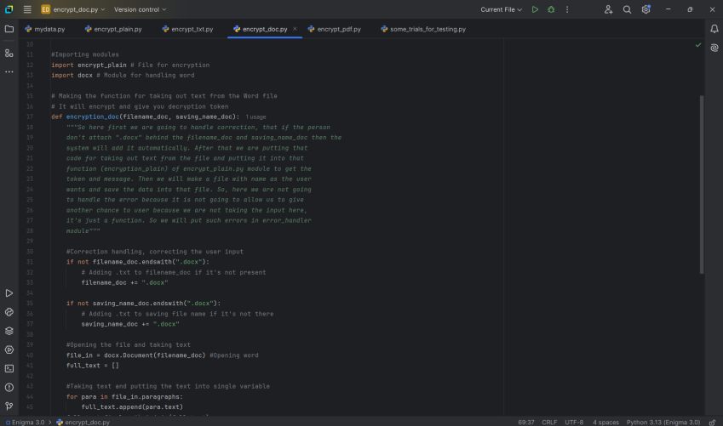
- So now I am starting with “encrypt_pdf.py”, and today we are going to complete the encryption part of the project.
- So let’s start with the last part of encryption, the challenge starts……….
- Now the encryption part is almost over, in last encrypt_pdf.py I used docx2pdf module to covert word where encrypted text of pdf is saved to pdf file. And I have used docx as well as pdfplumber module. As first I’m opening the pdf then taking out text of it then encrypting it then saving the text in a word file then making a pdf version of that word file.
- So there is a exception occurring in the encrypt_pdf.py, so now I have to work on it and find the answer……
- So in the process first it is opening the pdf, then taking text of it, then closing the pdf. And then making a word file and putting data in it and then saving it. Till here everything is going well, but problem comes when we covert the word document in pdf, so as I’m using “docx2pdf” module for this function then most probably I’m using it in a bad manner, so now I will check online resources, official documents and community helps.
- So I got the exception, I was in this line –
- #Saving the same file as PDF
convert(saving_name_doc, saving_name_pdf)
- And it was giving this exception –
- 0%| | 0/1 [00:00<?, ?it/s]Traceback (most recent call last):
File "D:\Coding\My codes (Python)\Enigma Series\Enigma 3.0\encrypt_pdf.py", line 89, in <module>
encryption_pdf(trial01, trial02, trial03)
~~~~~~~~~~~~~~^^^^^^^^^^^^^^^^^^^^^^^^^^^
File "D:\Coding\My codes (Python)\Enigma Series\Enigma 3.0\encrypt_pdf.py", line 75, in encryption_pdf
docx2pdf.convert(saving_name_doc, saving_name_pdf)
~~~~~~~~~~~~~~~~^^^^^^^^^^^^^^^^^^^^^^^^^^^^^^^^^^
File "D:\Coding\My codes (Python)\Enigma Series\Enigma 3.0\.venv\Lib\site-packages\docx2pdf\__init__.py", line 106, in convert
return windows(paths, keep_active)
File "D:\Coding\My codes (Python)\Enigma Series\Enigma 3.0\.venv\Lib\site-packages\docx2pdf\__init__.py", line 33, in windows
doc.SaveAs(str(pdf_filepath), FileFormat=wdFormatPDF)
~~~~~~~~~~^^^^^^^^^^^^^^^^^^^^^^^^^^^^^^^^^^^^^^^^^^^
File "<COMObject Open>", line 5, in SaveAs
pywintypes.com_exception: (-2147352567, 'Exception occurred.', (0, 'Microsoft Word', 'Command failed', 'C:\\Program Files (x86)\\Microsoft Office\\Office12\\1033\\WDMAIN11.CHM', 36966, -2146824090), None)
0%| | 0/1 [00:00<?, ?it/s]

- And it was there because in this laptop there is Microsoft Word 2007 and my program only work for word 2010+ models because of docx2pdf in it.

- Now I have added a feature where a person can use both, version 2007 or previous or latest, I have used libreoffice, it converts the docx to pdf.

- [17 April 2025]

- So last night there was a exception coming and I was confused that why is it there, because everything was fine there, then at the end I found that there was a line which I left uncompleted, so it was giving exception, the line was –
  - Subprocess.run(r“”)
- So here the subprocess.run the code, where subprocess is a module and while using its run function it do these thing internally –
  - First is open cmd
  - Then write the code just like a human have written practically
  - And copy paste the message the cmd returns
- So it’s just like a human have written it to the cmd and the code is executed.
- So here when I was running a empty str then it was thinking that what to do with this, it’s just nothing so as it don’t know what to do it gives exception and this problem was chasing me like a mad lover.
- Then everything was working fine then when I tested it then it made a doc_file and that’s it, there was no pdf file of it, so when I checked it properly then I found that when I was converting the word file I was making to a word file only. I didn’t wrote there pdf, then I updated it, here is its before and after code –
- 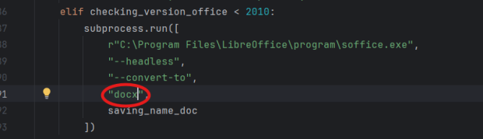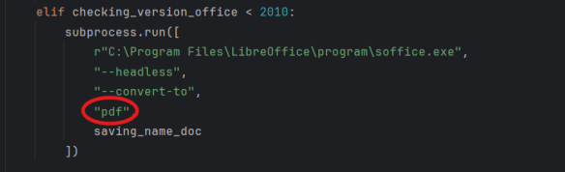
- And yeah that’s it, our encryption part of whole project is completed !!!!!, congratulation
- Means now 50% of code is done, 6/12, because that one module named “file_handler.py” is not going to be used in the project, because I felt that its code can be included with normal code only and nothing special is there that force me to make a special module for it. And now I have to start with decryption part. And now before starting the code of the decryption I have to check for logic of decryption, because no slowly the loopholes and problems will erupt and will for force me to change encrypt_plain.py. So, let’s see what happens next, and soon I’m going to start with decryption part.

- So let’s start with the logic of decryption, first we have to make a base on which it will decrypt the whole code. So let’s decide what will be its step and how it’s internal working would be –

  - It will have a list with keys, as the values are specialized for every message but keys are in same sequence. So we will save all the values of the keys in a list and just to remind you that the decryption token is made according to keys only and they will correspond with the keys that’s why keys have to be static and randomization of values will be equitant to the randomization of both.
  - Then that decryption token will be split by “key0000” as all the 6 keys are joined with “key0000” only, and as we will split we will get 6 keys in the same sequence we saved with.
  - Then we will covert each key to list
  - Then we will make dictionary where keys will be “key which we got from token” and values will be those keys which we had used to encrypt, we are just reversing the things, here (a to $ in encryption means that time it was a:$ and now this time it would be $:a) we are just making reverse dictionary of what we had made to encrypt message.
  - Then we will put same conditions of what we made for encryption, but this time it will be decrypted because of reversed key.
  - Then again it will be returning the message as per it was given, whether in text, txt, docx, or pdf, and the saving method and function would be same.
  - So for now I can’t complete it because of time scarcity…..I’m sleeping and this will be completed tomorrow.
- [18 April 2025]
- So now before starting decryption part I’m going to complete rechecking of whole encryption in next 30mins so that I can find any remaining bugs or anything else, then I will complete 1st part of decryption before sleeping again as its 3:00am and will try to complete more also if possible. So let’s start…..
- So while rechecking the whole thing, it’s taking a lot of time because a lot of things has to be checked
- While the time I was reading it, I got to know something interesting….So now days it’s better to use subprocess.run() then os.system() because os.sys makes the sys vulnerable to threats and subprocess is much better then it. Now subprocess is used in industry and os.system is for beginners.
- Just now while testing my decrypt_plain.py module I got a warning – “Shadows name 'decryption_token' from outer scope”. So I researched on it, a little bit and got to know some things –
  - When you initialize a variable at normal space (not in function or somewhere else) it is shadowing means making a global variable.
  - Then when you use a same named parameter in a function then it gives same exception, because now in the function you will not be able to use that global function.
- So while I was testing the “decrypt_plain.py” then I found a bug, there when I was writing a message then it was not decrypting them properly, like at some places instead of “!!!!!!!!!!!!!!!!!!!” it had “rrrrrrrrrrrr” so I started debugging and while debugging I found a loophole or another kinda bug. There was no space in the lists so space (“ ”) was represented by “ ” only. So, this was exposing th words easily, then I just added the space thinking that it was the bug and I fixed it. But not, when I retested the code then I found same bug laughing on me. Then I added print statement which would tell me which key was used for which character and it was converted into which character, and there I caught the bug red handed, I didn’t knew why it happened but I found the problem, so if I explain you with a example then there key 3 was used if the count was divisible by 4 and I had used “…………..” in my message so it used “rrrrrrrrrrrrrrrr” for all the dots, which means that those conditions weren’t working properly. Because if first dot was at 4th count then it was divisible by 4, but according to program even 5th 6th 7th 8th 9th …….. were also divisible by 4, so here is that problem and now I’m working on debugging.
- I have again tested it, and when encrypting this prompt – “hello hi happy heartday hugday” the whenever “h” was there then it was corresponding to “U” and every time key 6 was used, so it was impossible to be correct. And for space also key 3 was used, every time, and “ ” : ?, this was there every time, I think that the keys aren’t shuffling and all the keys are same or my if-elif-else logic is very incorrect.
- Now I have again tested the same thing without any change because I didn’t founf anything which was causing exception. All the dicts where special and had same sequence of keys but special sequence for values and I test encryption with “1111111111111111111111” and it returned “\\\\\\\\\\\\\\\\\\\\\\\\\” then I checked all of the count, condition, key and dicts then I found a thing, I observed a thing that my one of if statement was being used for key 1 and its condition was like this, that either your count should be divisible by 2 and not divisible by 4 and 5 or your count should be one, then I saw that key 1 was used for 1 at every count and when I checked the condition properly, then I found no loophole but still it was getting true for key 1 condition, and I don’t now that how did it even got true for composite count like 11 is a prime number but still it passed my composite check, But How !!!!!!!??????.........
- So I just got to know that when you are using “or” and “and” both in these conditions then its must that you have to use brackets otherwise python might mistreat it and I wasn’t using brackets there and now I think I have to use them so lets use them then check wether it works or not……
- Nothing changed…………even after putting some parentheses ….
- So this was the exception (in form of riddle 😊) –
  - "An empire built on letters and lies,
trusted a guard wearing a number’s disguise.
Two worlds clashed inside one gate,
yet one protector sealed the wrong fate.
Look deeper not at the walls,
but who guards the gate when destiny calls."
- So here is the code where exception was occurring (for someone who is looking this doc) –
- 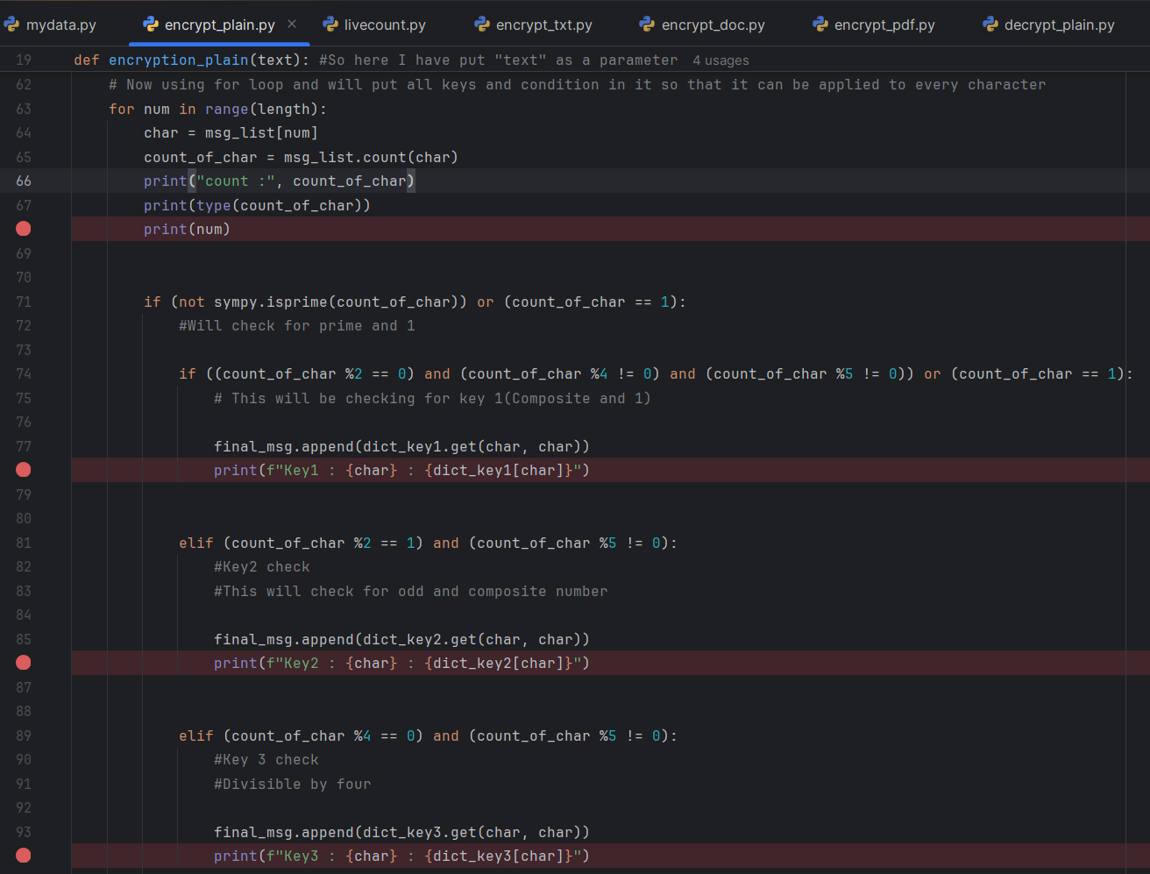
- In this code I wanted to get the number of times a character occurred up to an index but it wasn’t giving me the correct value, it was giving the same value every time. For e.g. in a list let me write the code –
  - List = [0, 1, 0, 0, 0, 1, 1, 0]
- Now I was checking for “0” count up to 5th index and in my code I wasn’t giving index to the program and was expecting that it will read my mind, me silly. And due to that I was getting the same value every time, as it was giving me total number of occurrence in the list. And it was destroying my whole code.
- I fixed it by making a custom function, I made a special module for that function so that it can be used in future. It has a very small and simple code.
- 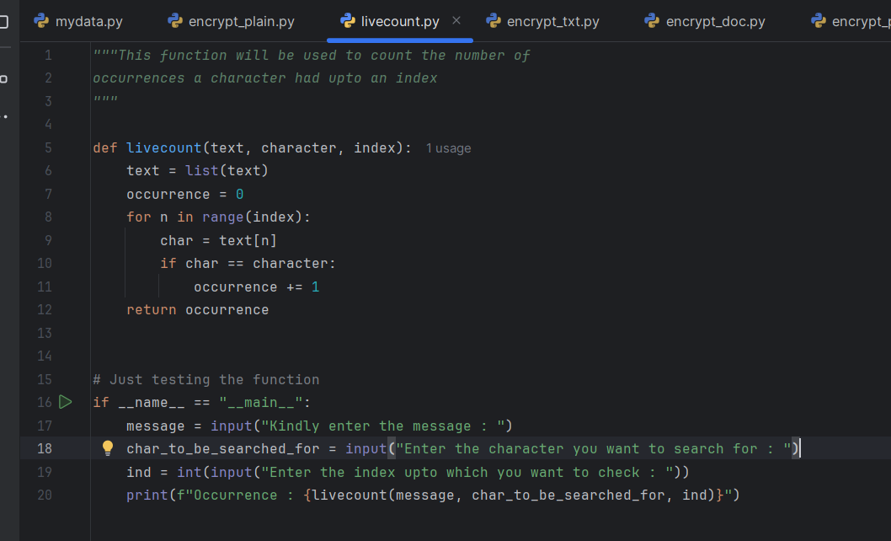
- No I’m fixing the code with the help of this function.
- [19 April 2025]
- Now that count problem is solved and it’s working properly but, when I’m comparing the dictionaries of encryption and decryption part which should be reverse of each other in a ideal condition, but in my case none of them are equal, means conversion from decryption token to dictionary is causing problem, the bug is stuck somewhere here only and it may be in making of decryption token also.
- So now I will check the things one by one –
  - Making of decryption token
  - Disassembling of decryption token
  - Making the dictionary from decryption token
- # So I’m back from school, and I have to do a lot of school work and have to prepare for tests also but, “harami maan mane kaha” and again I’m sitting for coding….haashhhhhhhhhh…..
- So let’s start with debugging…..
- So our problem was that the dictionaries aren’t made properly from the decryption token…or some other which we have to find……
- So just now I have checked that whether the reversed dictionaries are actually reversed or there is some problem in breaking the decryption token to make a reversed dictionary. So, I just took the original dictionary of a message and also took the dictionary which was made from the decryption token of that message, then I reversed the dictionary it made from decryption token and when I used them at a website which checks for the difference between text, then I found that there was no difference, and both dictionaries were exactly same, and now I can conclude that the dictionaries made from decryption token are perfectly reversed and can absolutely be used for debugging.
- So we can also conclude that there is no problem in making normal dictionaries from special keys and reversed dictionaries from decryption token, so where is the problem ?, We can have some assumption that where is the problem, and if any of them is true then celebrate or find the bug, so my assumption is that it is in conditions, means the guards are wearing disguise and allowing the entrance of enemies……so let’s find it….
- Finally!!! Finally!!! Finally!!! I have find and fixed the bug, it took me ours, literally hours. I was sitting and staring the code and after a lot of work, continuously, without any help of chat GPT, even I asked for a riddle as a hint but it didn’t helped me much. And at the end, tears were there in my eyes, on finally solving it after a lot of hard work. But there is also a brutal truth, that in between, I haven’t spent much time on match or something else, it was even less than 30 min but brave don’t fear in confessing the mistakes. And now I’m going to write my mistake while debugging which let me took so much time and it will allow me to correct them from next onwards –
  - Breaking the flow – Even I saw match scorecard for less than 5 min at a time but still it breaks the flow and connections which were made to solve the problem.
  - Staring the screen – Many times I was going blank and this was wasting a lot of time, and I was getting lazy for next step so I have to stop that.
- So now let’s get back to the bug, so what was the bug, so there were two bugs in the conditions, first was in 2nd sub condition where I wasn’t adding the condition for odd count and it was passing the character to 2nd key only and 3rd key was in less use and it was causing problem. Then the 2nd bug was that in 4th sub condition I was adding a condition which wasn’t allowing the odd nums to pass through it and it was for divisibility of 5 and it was making a chaos situation where I was not passing thorough that condition and was passing to else, which was for overlapping condition. Now finally I have completed the debugging of “encrypt_palin.py” and now I can pass to decrypt_plain.py and make the same changes in it as both had same conditions and now that’s it lets move on….. while fixing the decryption part I remembered that there was one more bug in a condition so in them I had added extra condition which was causing the problem. So now let’s back to the decryption part.

- [20 April 2025]
- #So it’s 3am and I’m completing the project.
- So I had completed the decryption part as encryption one and then when I again tested thinking that all good then I found that a bug is still there, sucking my blood like a leech.
- So bug is nowhere but in dictionary creation and usage but when I had took the original dictionary and compared it will dictionary of decryption part made by that token then the decrypt dictionary was perfectly reversed and this means that there is a bug in dictionary usage not creation.
- So just now I have done something big to make the code stable, better, cleaner, less chaotic and easier to scale. So when I was planning for this project even before execution then at that time in my mind the logic was that which key to be used will not depend on count instead it will depend on index and slowly I shifted to count, I don’t know how but I did and now it’s very chaotic is no more upgradable so I’m shifting back to index and this time it may reduce its security, just a little bit. But now it will be way to scalable and upgradable and we can depend and find other logic to make it stronger instead of depending on this index and count. Because either you use count for more security for now and make it un-scalable and un-upgradable or use index and latter add better logic to it to make it more secure. So now I’ve converted it for index and now I have to change all the messages to make it better and proper.
- And if I don’t shift then it will take a lot of time and my learning is stopped due to this project and I will not be able to learn new things as I can’t leave this project in between and yeah I have to start new learning as soon as possible.
- Now everything is done and I’m sleeping.
- I’m back and I’m back and I’m back after debugging the whole code, I gave a lot of time and I have completed - 😊😊
  - encrypt_plain.py
  - encrypt_txt.py
  - encrypt_pdf.py
  - encrypt_doc.py
  - encrypt_pdf.py
  - decrypt_plain.py
  - decrypt_txt.py
- So just to remind myself, I want to confess that from past 2-3 days I’m wasting 2 to 3 hrs of the day in useless things and these will be the reason of my failure ☹☹ if I fail in future and that time I will regret and will blame god ☹ that why I failed as in such conditions we don’t remember that when we had wasted the time even though we did. So kindly don’t waste time and focus on instead of wasting more than enough time then we should. So now I’m completing the remaining module, not all but the decryption part. 😐😐
- Congrats!!! Congrats!!! Congrats!!! Finally the decrypt_pdf.py is also over and now I’m moving forward to decrypt_doc.py 😊😊
- Finallyyyyyy!!!!!!!!! my whole decryption part is over and tested. Congrats and now tomorrow I have to complete remaining 3 modules, so here is the stats of all modules –
- Mydata.py — ✅ Completed and Tested
- Main.py — ⏳ Remaining
- Exception_Handler.py — ⏳ Remaining
- Encrypt_txt.py — ✅ Completed and Tested
- Encrypt_plain.py — ✅ Completed and Tested
- Encrypt_pdf.py — ✅ Completed and Tested
- Encrypt_doc.py — ✅ Completed and Tested
- Documentation.py — ⏳ Remaining
- Decrypt_txt.py — ✅ Completed and Tested
- Decrypt_plain.py — ✅ Completed and Tested
- Decrypt_pdf.py — ✅ Completed and Tested
- Decrypt_doc.py — ✅ Completed and Tested
- So now I have to complete Sanskrit work else sir will kill me so for today that’s it 😊

- [21 April 2025]

- So I’m back from school and starting study very late because I was doing some other important work but now I’m back and now one my friend was just demotivating me towards for my project that it isn’t that powerful and I can easily break it, secret module is also there which is much better then this and was trying to make me feel low for this project but I don’t care about such people and I don’t like to call them friends but still he is a good one so I can ignore this much. Another thing is that, I don’t want anyone’s validation on how good is my project, how am I looking, how secure is my project, etc because I believe my skills, intention and vision. I know what is right and what is wrong. They feel jealous so they just don’t want to face my success and I don’t care about them. If you want to work with me then grow together or get lost.

- Exception Handler –

- So now I’m starting with exception handler module and first I’m learning on how to make a custom exception and I have planned some exception handlers, and here they are –

  - Length not matching exception – Here we will check for length of token, if it don’t matches with necessary length which is 95 + 7 + 95 + 7 + 95 + 7 + 95 + 7 + 95 + 7 + 95 = 605 then we will ask user for token again.
  - File not found exception
  - File already exists exception
  - No message exception – If there is no message then we will give this exception, like if user gives unexpected
  - Unexpected exception – This will be for all the other exception that can be there, so that if I left with any exception then it can control or manage it.
  - File contain no text exception
- So just now another Idea popped into my mind that if user finds any bug in my project then they can report it to me on my website and we will use simple “mailto:” link and it will be like this – “mailto:devsaini4752@gmail.com?subject=Bug%20Report%20for%20Enigma%203.0&body=Please%20describe%20the%20bug%20here” and it will be a great and professional feature and will be useful after I public it. And yeah that’s it but first let’s get back to exception handler.
- So I’m having a severe headache because of lack of sleep and now as I’m feeling better so I’m thinking of continuing the project, though I have to learn about a chapter of English which maam gave as punishment but again “sankat sar pe hai, par harami man mane kaha”. So for now I’m learning how to make custom exception and after that I will just read whole chapter.
- So after this project I have to learn –
  - OOP
  - Dunder methods
  - Constructor
  - Decorator
  - Modules
  - Data handling
  - Custom exceptions
- So for custom exception first we have to make a class for that exception with its name and we can put messages in __init__ method and while you are making the class you have to inherit “Exception” class form it, which will make it a official exception then we can call the __init__ function of Exception class by super() method to call the __init__ function of exception and there we will put the message variable and yeah that’s it…..may be, not sure, now learning from YouTube or somewhere else.

  - Example
  - class MyCustomException(Exception):
  - """Exception raised for custom exception scenarios.

  - Attributes:
  - message -- explanation of the exception
  - """

  - def __init__(self, message):
  - self.message = message
  - super().__init__(self.message)

- [22 April 2025]
- So I’m back, it’s 3am and now I’m doing to complete exception handler as yesterday I wasn’t able to. And I have already made my first exception, which is LengthException and here is its code and executed example, just as a reference -
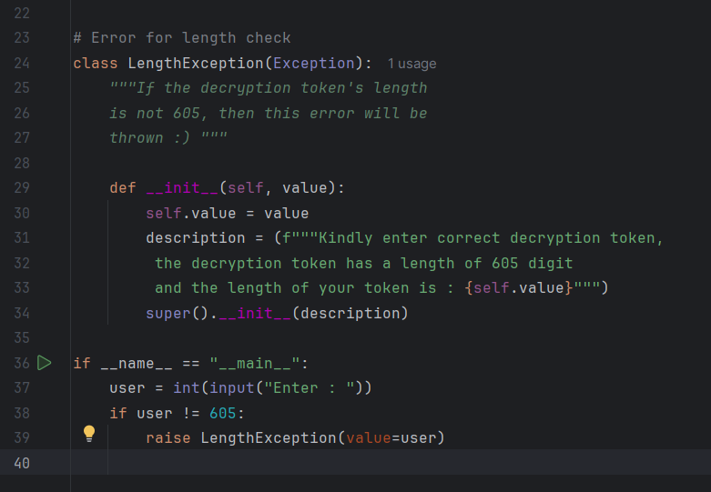
This is the code for -exception
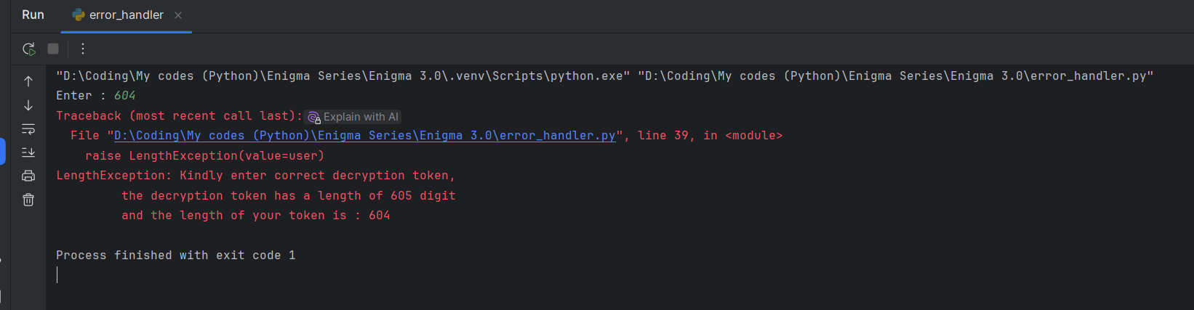
The exception -
- Now I’m making remaining exceptions and will read all the other modules again to get more exceptions 😐😊
- So I have completed the error handler file and made all the errors and now I’m leaving as I have to go school also, will talk about this error handler and other planning later.
- I’m back but very late because in school I had been scold a lot and I had to complete the work so I wasted a lot of time in completing work but now I’m back and I’ll not discuss a lot and now also I can’ do more…..b’coz of some reason..

- [23 April 2025]
- So I’m back, finally now I’m well, from past 4 days I was having severe headache, body ache, mental fatigue, muscle fatigue and other problems like school work, but now I’m free from all of them and now I’m well so let’s continue the project and complete it by tomorrow.
- So today I’ve completed the “error_handler.py” module and all messages and everything is done and now I’m shifting to documentation.py and I may complete it today only, “may” because today mum took a lot of my time in some work so very less time is left so without any rubbish talk let’s get back to topic and I’m starting with documentation. So what will be there in documentation module
- Things which documentation.py should include –
  - Title & Project
  - Intro
  - Feature
  - About module Structure
  - How to use
  - System Requirements
  - Limitations (If you want)
  - Future Improvements
  - Credits
  - License
  - Personal Message
- So I’m going to make it in .txt file and will add all these things in detail……
- So I have completed the documentation and sorry for now I can’t explain things in detail I’m getting late, as I have to sleep and it’s getting late and will talk to you later bye 😊

- [24 April 2025]
# Bye the way it’s 3:00 a.m.
- So I’m back and before coming here I have worked a little bit and now only last module “main.py” is left and rest is completed and this is the updated list –
  - Mydata.py — ✅ Completed and Tested
  - Main.py — ⏳ Remaining
  - Myjourney.py — ✅ Completed and Tested
  - Exception_Handler.py — ✅ Completed and Tested
  - Encrypt_txt.py — ✅ Completed and Tested
  - Encrypt_plain.py — ✅ Completed and Tested
  - Encrypt_pdf.py — ✅ Completed and Tested
  - Encrypt_doc.py — ✅ Completed and Tested
  - Documentation.py — ✅ Completed and Tested
  - Decrypt_txt.py — ✅ Completed and Tested
  - Decrypt_plain.py — ✅ Completed and Tested
  - Decrypt_pdf.py — ✅ Completed and Tested
  - Decrypt_doc.py — ✅ Completed and Tested
- So yesterday I wasn’t able to talk much about that documentation, so yesterday I had completed the documentation and there I had written the whole thing in detail, explaining my project and in a professional way and it had following things –
  - Heading
  - Introduction
  - Features
  - About Modular Structure
  - Maintainability, Scalability and Readability
  - System requirements
  - How to use
  - Limitations
  - Future improvements
  - Credits
  - Personal message
  - Ownership
  - Contact
- Yeah this were the things in it, here I have explained everything which should be known to the user or another coder using this, and the documentation.py I’ve just made a function which prints all the text of the file and also opens the file.
- Here is a look of documentation –
- 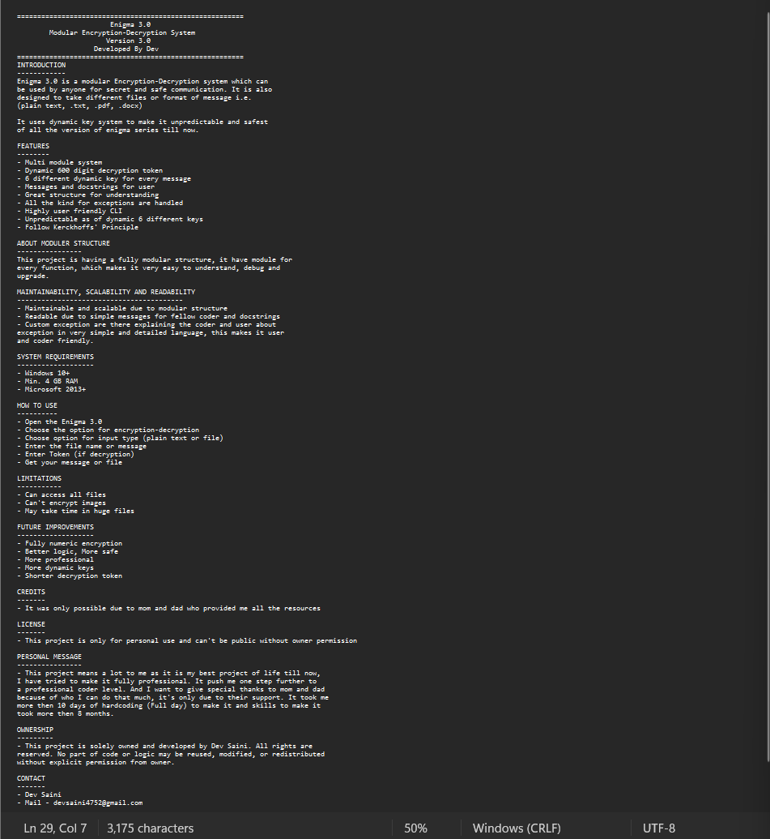

- Just now I have completed one more file which opens this Enigma_3.0_journey.docx so that user can know about me….
- Hi User!! how are you ?

- So now I have to complete the last part which is the main.py the main engine of the program which will connect the entire program and will run them. So without wasting any time I am starting with it……

- So I have started with main.py and while making it, though I haven’t even started properly but a potential problem popped in my mind that for multiple chances I will use loop, so that even if user chooses wrong option then also they can get another chance but after they will choose the option they will be asked for encryption or decryption and for the same reason I will have to use loop and I fears that it may creating a problem of nesting of loop that can cause debugging problems, readability and many more problems. So I will think about it in school, as for now I have to sleep or I will be late and my sleep will not be completed 😊

- I’m back from school and I have just updated the documentation a little bit, just added logic of program and now I’m starting with main.py and it might get completed today 😊so lets goooo……

- So I have finalized the structure of the main.py in school only and it’s like this and this will be the structure which user will see and use –

- Phase 1-

  - Encryption
  - Decryption
  - Documentation
  - My journey (Owner journey)
  - Exit

- Phase 2 (for encryption and decryption as doc., my journey, will just open the file and exit will close the program)-
  - Docx
  - Pdf
  - Txt
  - Plain Text

- Phase 3-
  - Decryption token (if decryption)
  - Message/ Filename
  - Saving file name (if file)
  - Word version (if docx)
- Done that’s it 😊
- So let’s execute the planning in main.py
- By the way I have made another module named as colours an module where I have made different variable with ANSI code and they will be used to make the CLI interesting.
- So my main.py is completed 😊 yeahhh boy!!!!!!
- #I have used chat GPT to change colour of text, nothing else then that. And that was also because I have a very bad colour sense ☹
- Now I have to only add those custom error systems 😊 and it will not take much time 😊
- ☹☹☹
- So I had completed the whole main.py and I was happy but I had made it’s structure very bad like a piece of shit and now I can’t except that thing so I’m remaking the whole main.py and I have very short time period and tomorrow mom will take away laptop so I have only 3 hrs so bye I am restarting……
- So the final_main.py will be divided into some sections –
- Section 1-
  - Encryption
  - Decryption
  - Documentation
  - Developers Journey
  - Close
- Section 2 (Encryption)-
  - Plain text
  - Txt
  - Docx
  - Pdf
- Section 3(Decryption)-
  - Plain text
  - Txt
  - Docx
  - Pdf
- Section 4(Documentation)
- Section 5(Documentation)

- [25 April 2025 – 2:25 a.m.]
- #Good Morning, now I will not be able to write much because I have to complete this and time is very less so for now documenting time isn’t there, sorry!
- I can’t talk much but when you will come back from school kindly edit that error handler module. Make another function in it which will check that which error has to be raised so that we don’t have to write a lot in main.py…..sleeping… bye!!!

- [29 April 2025 – 3:05 a.m.]

- So I’m back!!!, The laptop was taken by mom and she was not at home from past 2-3 days so I was doing coding in PC and there Microsoft word wasn’t installed properly so no editing option was there. But now I am back and I have officially ended the Enigma 3.0. So I have added following features since I wasn’t writing in this document –

  - ASCII Art in intro and outro
  - A little bit animation
  - Testing
  - Added feedback option
  - Extended colour module
  - And many things which I don’t remember by specific

- So finally!!! The enigma 3.0 is officially and now I have to just combine it and make a .exe file to keep it like a application. But before that here are some visuals of its beautiful entry and exit…
- Entry….

- 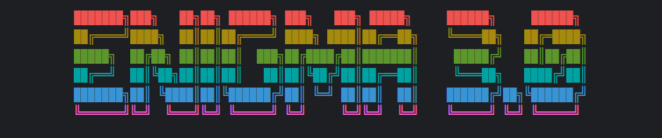

- Exit…..

- 

- In all places I have chosen the colours very wisely with the help of chat GPT because my taste was very bad and to keep it look good………

- I have added the animation in starting by this function, the explaination is also given here only so read it if you want to……
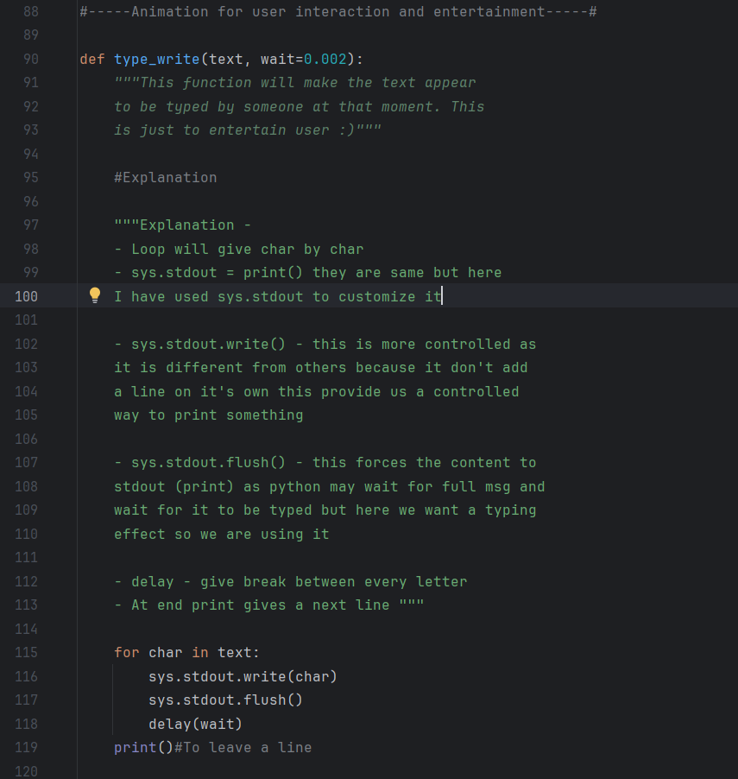
- Now let’s start the process of .py to .exe……
- So the logo is done and here is its glimpse of it and now I’m leaving 😊 will never be back for this project, the whole thing will be in .exe by this code - pyinstaller.exe –onefile --add-data "Documentation.txt" --add-data "Enigma_3.0_journey.docx" .\main.py

- Logo-

- 

- So now I’m back, I had slept as it was 5:00 a.m. and now I have to solve another problem, that when I had made this whole project to .exe then it was done by pyinstaller and it’s just a “jugaad” because in reality .spec is used, so I will search for it later as of now I have to complete this project. So, when I was using pyinstaller in this process then what pyinstaller does is that is whichever dependencies where there then they are only downloaded with this when they are imported in main.py i.e. the file which will be converted into .exe and other would be its dependencies.

- This is the error which was erupting after I had made that exe file but some important file of it was missing.
- 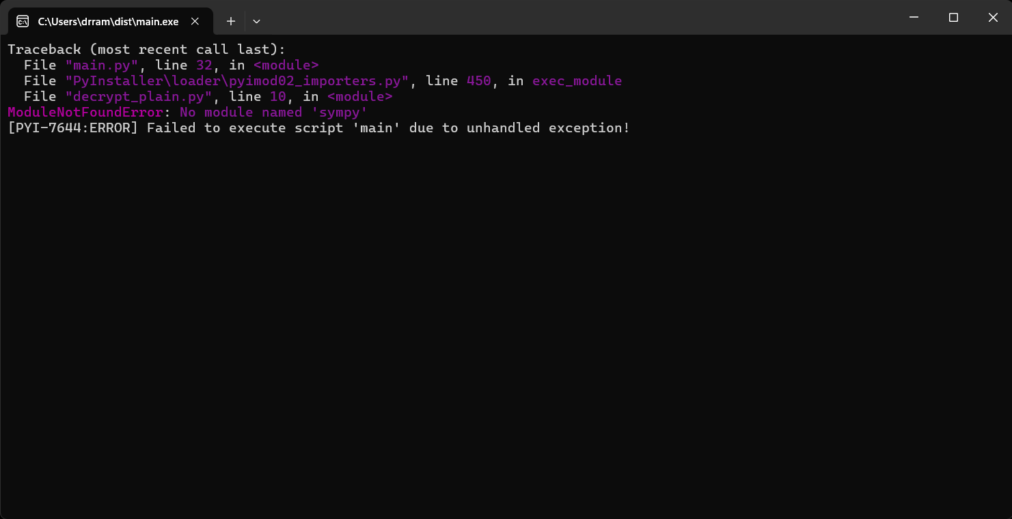

- So there where many modules, internal as well as external which were imported in other modules and those modules were used in main.py. And problem comes here only that pyinstaller don’t download the indirect files so now I’ve 2 options that either I import all the modules in main.py whether they are used there or not and other option is that I can manually add all those file in main.py with the help of “—hidden-import module”
- So there is no problem in internal module because even if internal module is indirectly imported (for e.g. mydata.py is imported in encrypt_plain.py but not imported in main.py and we are making main.py as a main execution point which will be opened when the person will click file and other will be just dependencies, so here it will import mydata.py automatically) so no problem is there in internal module and they are also located in same directory to chances of error sompletely ends and now when we talk about external module then even if it is imported in mian.py, directly, then also we will hidden-import them to make it error – proof 😊 many times pyinstaller don’t explore them properly. Another thing is that we don’t need to hidden import the in-built modules only third party modules should be used 😊
- So this is the list of all the external modules used in whole project-
  - Docx
  - Docx2pdf
  - Pdfplumber
  - Sympy
  - String
- Now there is another problem, when I’m making a exe file then it has these journey and documentation file but when we run it, then it store the documentation and journey file or even in usual case it stores the file to a temporary file which has a completely different path and it make that temporary file in your local storage and now I have to fix it, initial I was using a relative path but relative path don’t work here because file is formed out of the file so we can use absolute path but I may cause error if the exe file is not stored at a proper place and user may not know about that so I have to make a completely different system which I’m learning……

- So here I will be using a __file__ variable which stores the path of the file where it is used
Important topic I just learned 😊-
- Here is the code and explaination –
  - Code –
    - import sys
    - import os

    - base_path = getattr(sys, '_MEIPASS', os.path.dirname(os.path.abspath(__file__)))
    - file_path = os.path.join(base_path, "Enigma_3.0_journey.docx")
  - Here first we are making a base path, where we are using a in-built variable (__file__) which gives the full path of the file where it is used, so we take it’s abs path to confirm that the path is no relative. And it removes the file name so that we can put the filename we want by the (os.path.dirname, it just gives path till directory).Then when we talk about BTS then there the .exe file is like a magic folder where a main file is executed and other files are stored in a temporary directory named “sys._MEIPASS” when we use the getattr() in-built function that takes (object, attribute, fallback) and it so sys is the object and _MEIPASS so this sys is a module who has a attribute named _MEIPASS which is only there until file runs so exe use it as a temporary folder. So first is getattr() opens the _meipass and if it is not there then it gives the path of file and then in that path or _meipass folder then it add the file name and yeah that’s it then the file can be accessed easily.

- So yeah that’s it, now tata……
- So no I’m going with it and if I return then some error have occurred otherwise it happened successfully 😊 bye-bye!!!
- And this is just the journey and if you feels something awkward or senseless then keep that thing to yourself because everyone have a different thought processing.
- Bye!!! And if you are user and you are reading this then thanks for reading!!!

- ###---------------------------------------Official ending at [29-04-2025 15:34]---------------------------------------###

